Change Order Request
February 15, 2016

Merrill Gardens at Ballard, LLC
111 N. Post, Suite 200
Spokane, WA 99201
Attn: Bill Robinson

Re: Merrill Gardens at Ballard – Change Order Request #10 – RFI-175 Added Sink

Bill,

Please see cost breakdown below to add a P-5 sink to the warming kitchen serving bar. Please issue an official Change Order at your earliest convenience. Let me know if you have any questions or require further information. Thank you.

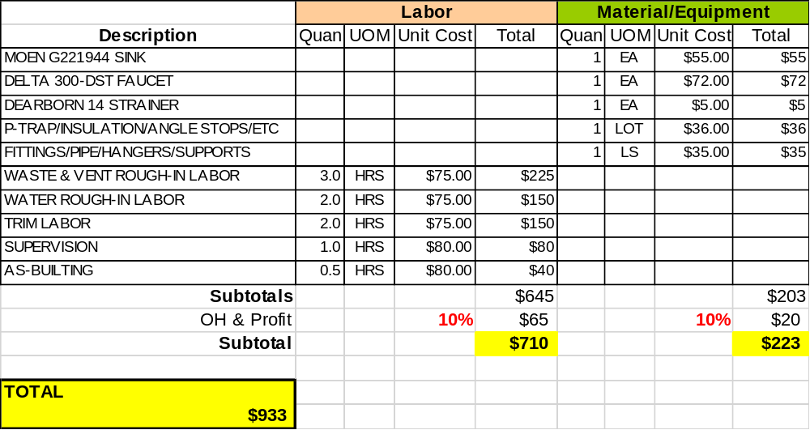

Sincerely,
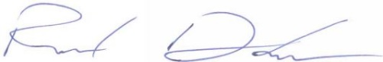
Richard Donelson
Project Manager / Estimator
richd@owpllc.net
425-591-4296 cell

